**MainActivity1** **2**

**MainActivity2** **3**

**MainActivity3** **4**

**MainActivity4** **5**

**MainActivity5** **6**

**MainActivity6** **7**

**MainActivity7** **8**

**MainActivity8** **9**

**MainActivity9** **10**

**MainActivity10** **11**

**MainActivity11** **12**

# 

# 

# 

# MainActivity1

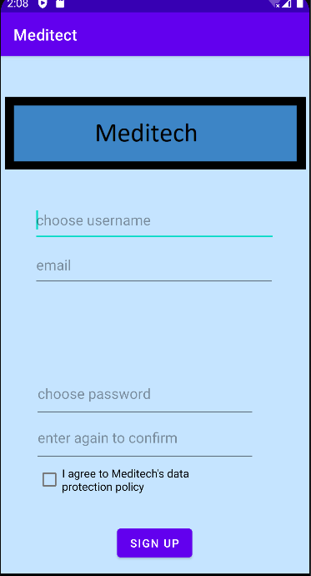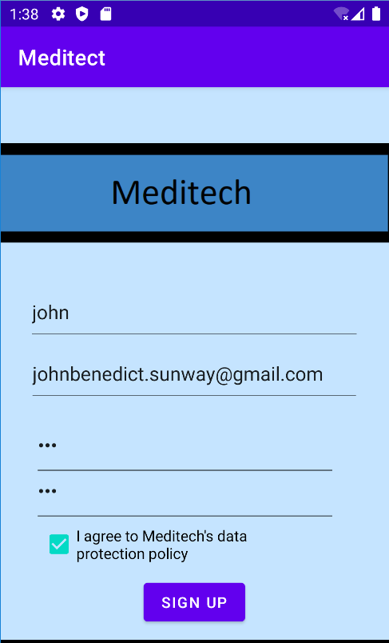

Text boxes work

Check box works

The signup button works as shown by the navigation to the second screen (shown in activity 2)

# MainActivity2

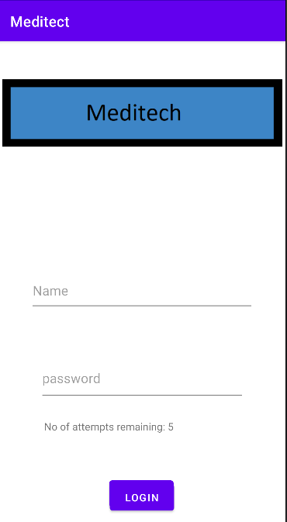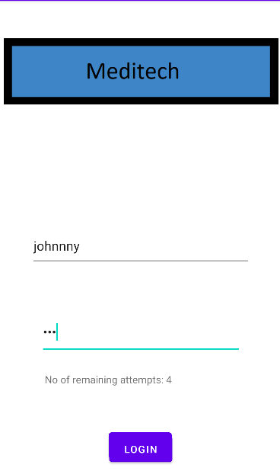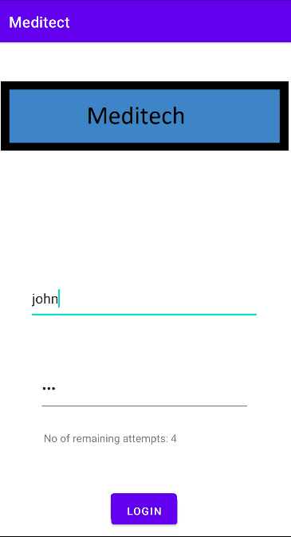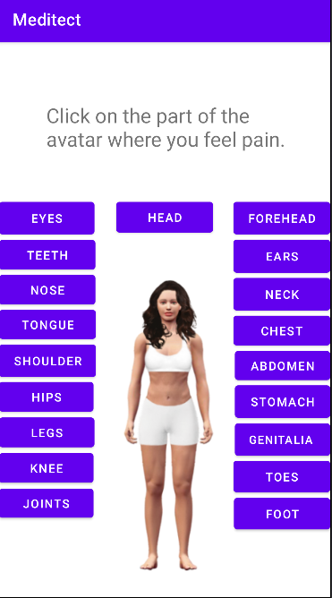

Text boxes work

Entering the wrong username decreases the number of attempts left (shown in 2nd screenshot)

Entering the correct username sends the user to the 3rd screen (4th picture)

# MainActivity3



Button for eyes work (see MainActivity4)

Button for stomach work (see MainActivity6)

Button for genitalia work (see MainActivity7)

# MainActivity4

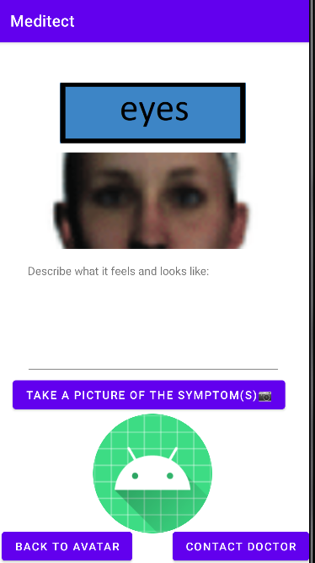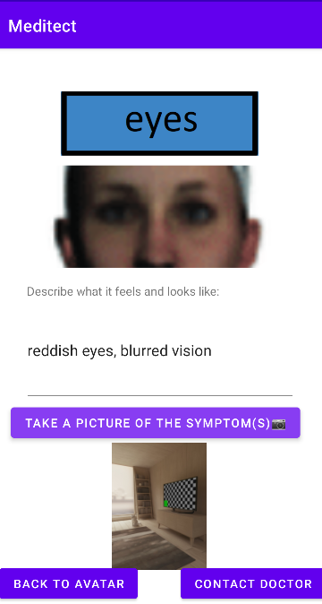

Text box work

Camera button works as seen by the image taken (shown in image view box)

Image view works(shown in 3rd picture)

# MainActivity5

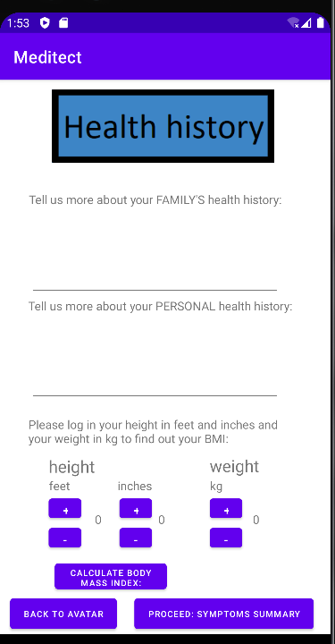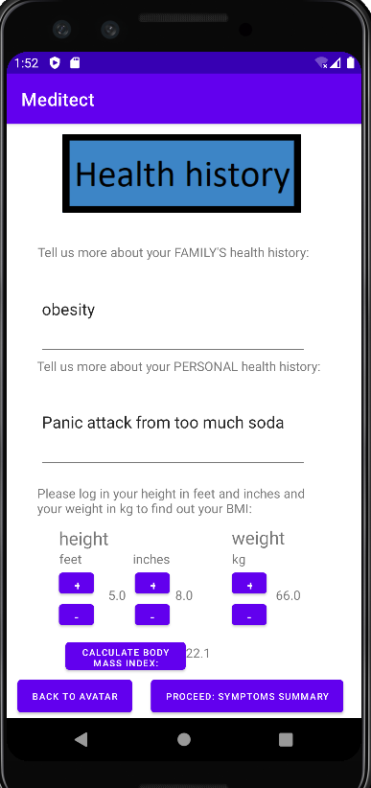

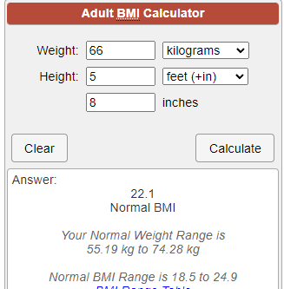

Text boxes work

Button for height (foot and inches) work

Button for weight works

Calculation works

Display for calculated figure works (2nd picture)

3rd picture shows that the calculation algorithm is accurate to 1 significant figure

# MainActivity6

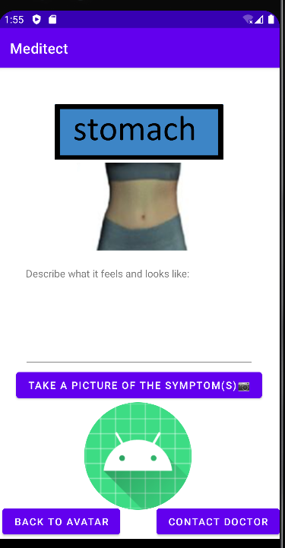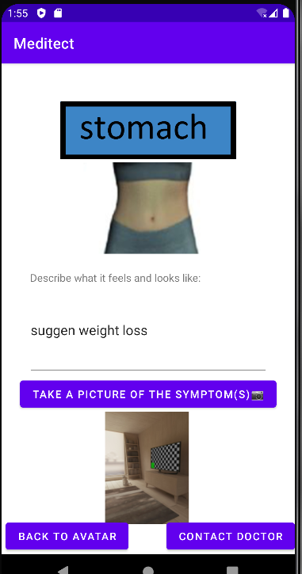

Text box work

Camera button works as seen by the image taken (shown in image view box)

Image view works(shown in 2nd picture)

# MainActivity7

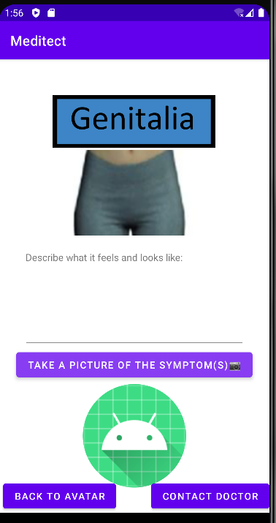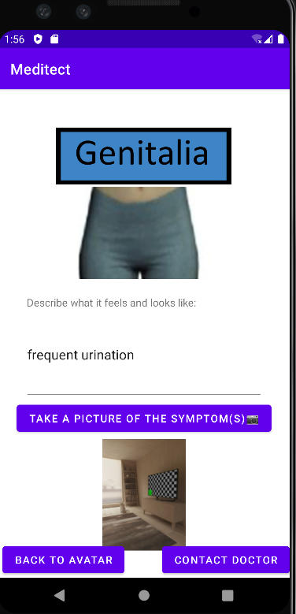

Text box work

Camera button works as seen by the image taken (shown in image view box)

Image view works(shown in 2nd picture)

# MainActivity8

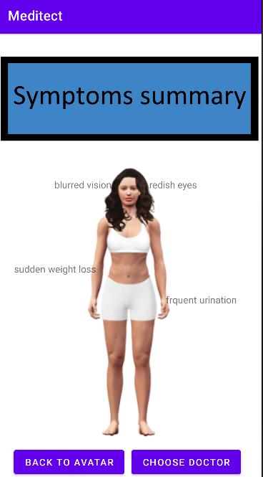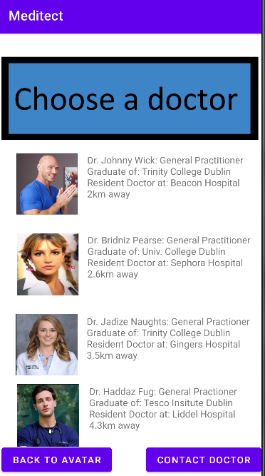

Text views work

Choose button works:brings you to mainactivity9 as shown in 2nd image

# MainActivity9



Clicking on image brings you to MainActivity10 as shown in 2nd picture

# MainActivity10



Text views work as shown in the image above

Button works and brings the user to MainActivity11: Diagnosis (see MainActivity11)

# MainActivity11

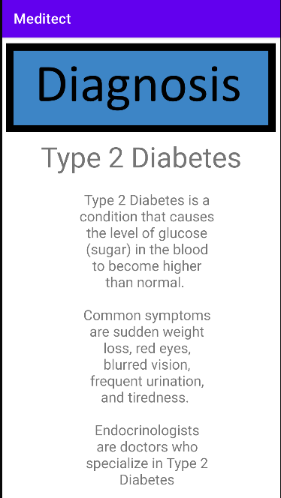

MapsActivity